Creating a Wilma account for the guardian and connecting a child to the account
1. To make a Wilma account, start at https://nurmijarvi.inschool.fi/connect. Be ready to provide strong identification with, for example, your electronic banking codes.
2. Enter your e-mail address, which will be used to verify your login. The e-mail address you enter will be your Wilma ID. Finally, click Send verification.
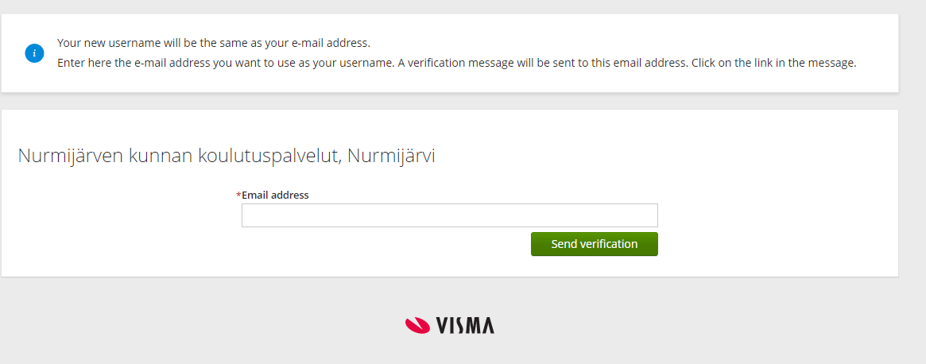
3. After the verification has been sent to your e-mail, you will receive the notification pictured below.
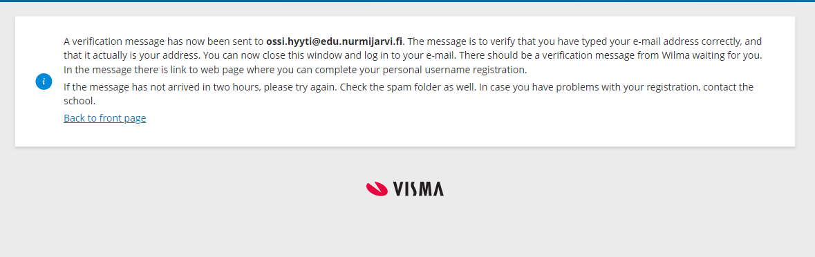
4. Sign into the e-mail account you sent the verification to. You will receive a verification e-mail with a return link from wilmanoreply@nurmijarvi.fi. Use the verification link to return to the Wilma login screen. If the e-mail does not appear in your inbox, check your spam folder and, if you still cannot find the e-mail, your other e-mail folders as well. The e-mail may take longer to arrive on Gmail accounts. If you do not receive the verification e-mail at the e-mail address you entered within 24 hours and it is not in your spam folder, please contact Wilma support (040 317 2413 or wilmatuki@nurmijarvi.fi)
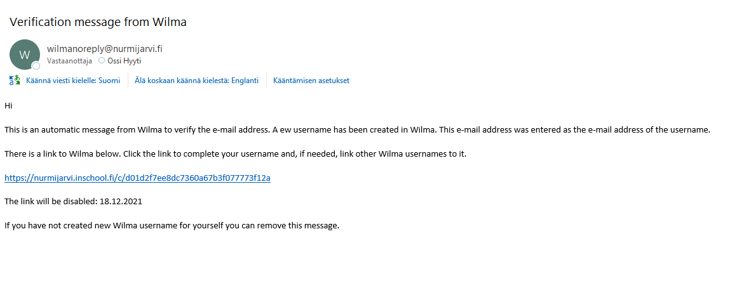
5. You will receive the notification pictured. Click Next.
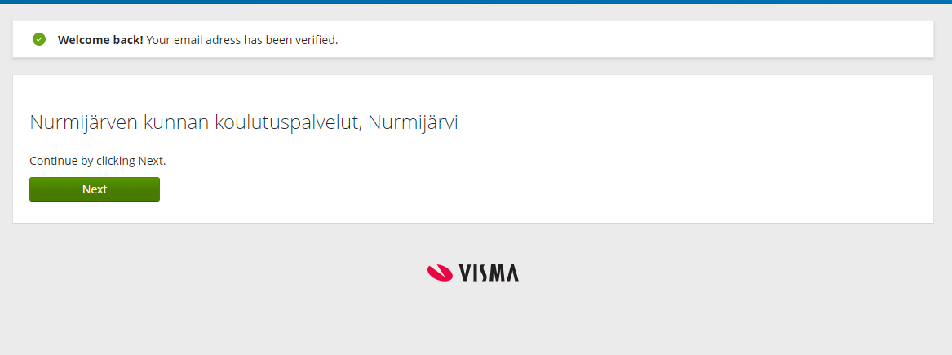
6. School
6.1. If you are enrolling your child in pre-primary education, select Ilmoittautumiskoulu (Enrolment school) from the list.
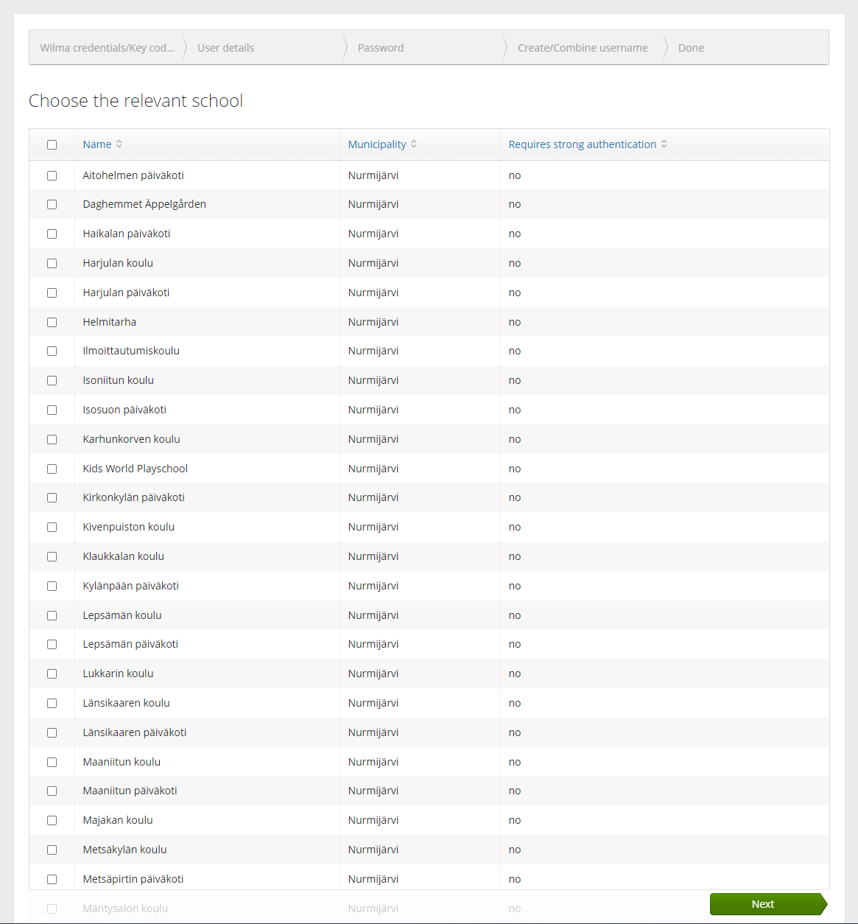

7. You will receive the notification pictured. Click To the identification. Note: Do not click Skip – you will not be able to set up your account.
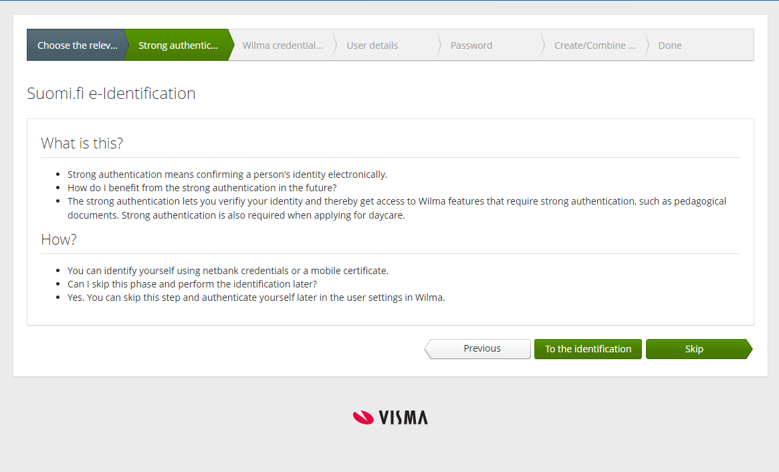
8. Select your identification method and complete the identification process.
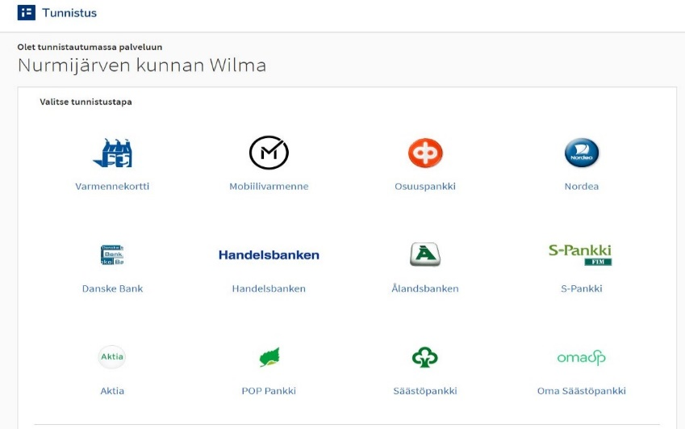
9. After identification, you will receive the following notification. Click Jatka palveluun (Proceed to service).
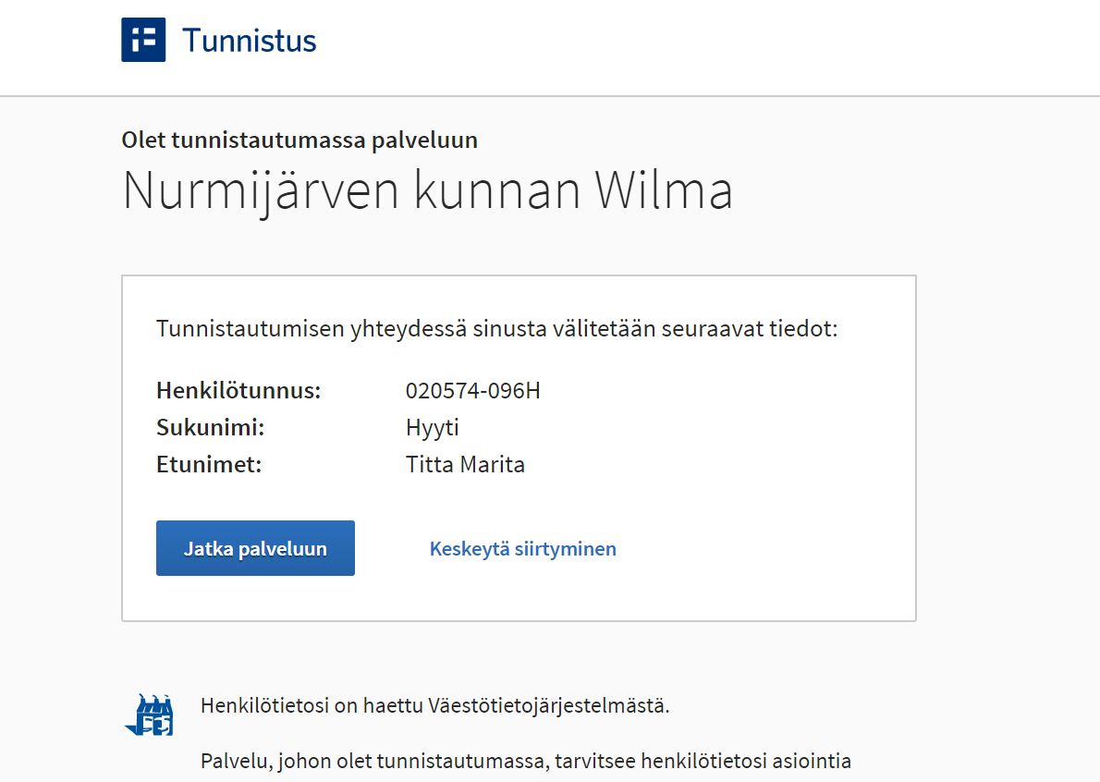

10. You will receive the following notification.
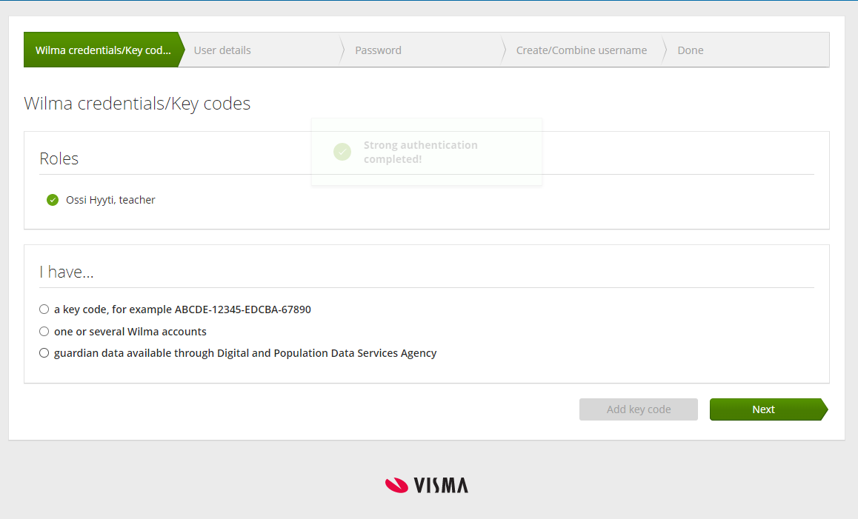
11. Click ‘​guardian data available through Digital and Population data services Agency’ and Retrieve person.
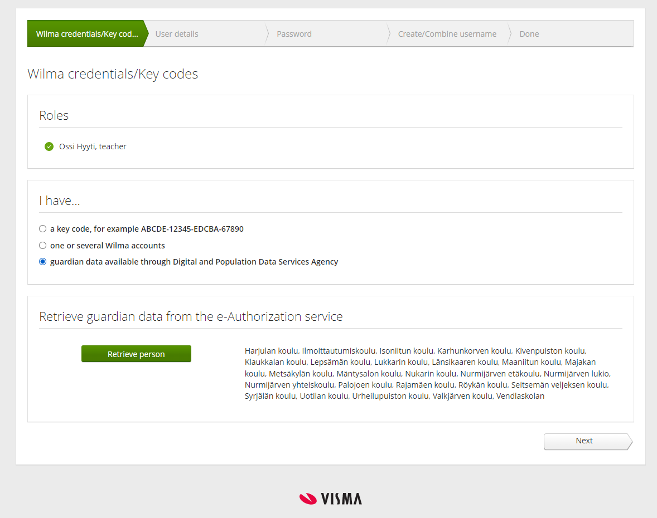
12. You will receive the following notification. Select a child to connect to your account. Confirm and continue.
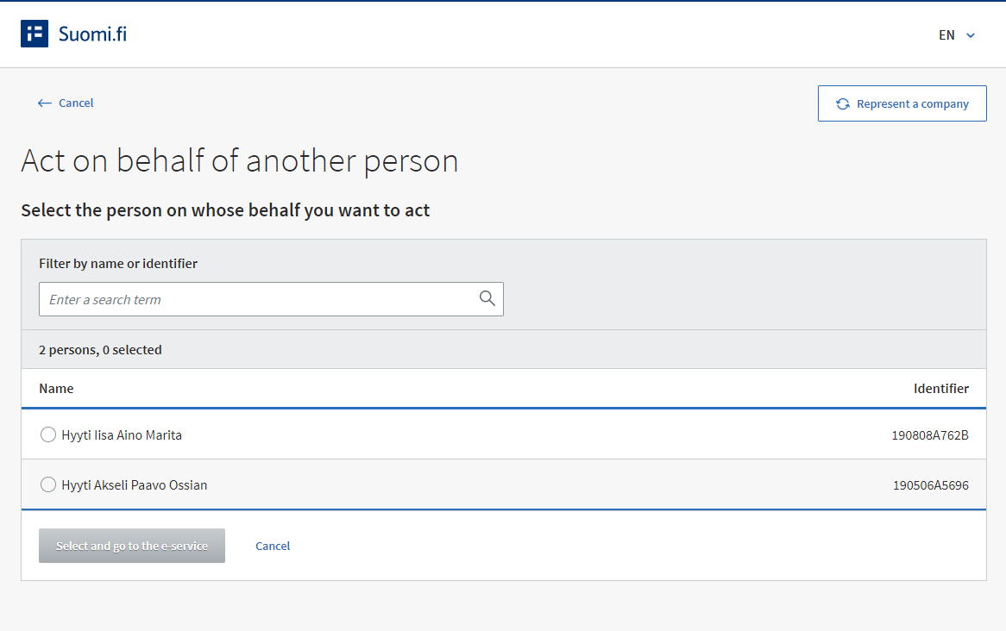
13. The next screen will display the children you have connected to your account. If you have several dependents you wish to connect but only one is shown, click ‘​guardian data available through Digital and Population data services Agency’ again and then click Next. Repeat sections 12 and 13 until all the children you wish to connect to your account are displayed on the Wilma credentials/Key codes screen. Finally, click Next in the screen below.
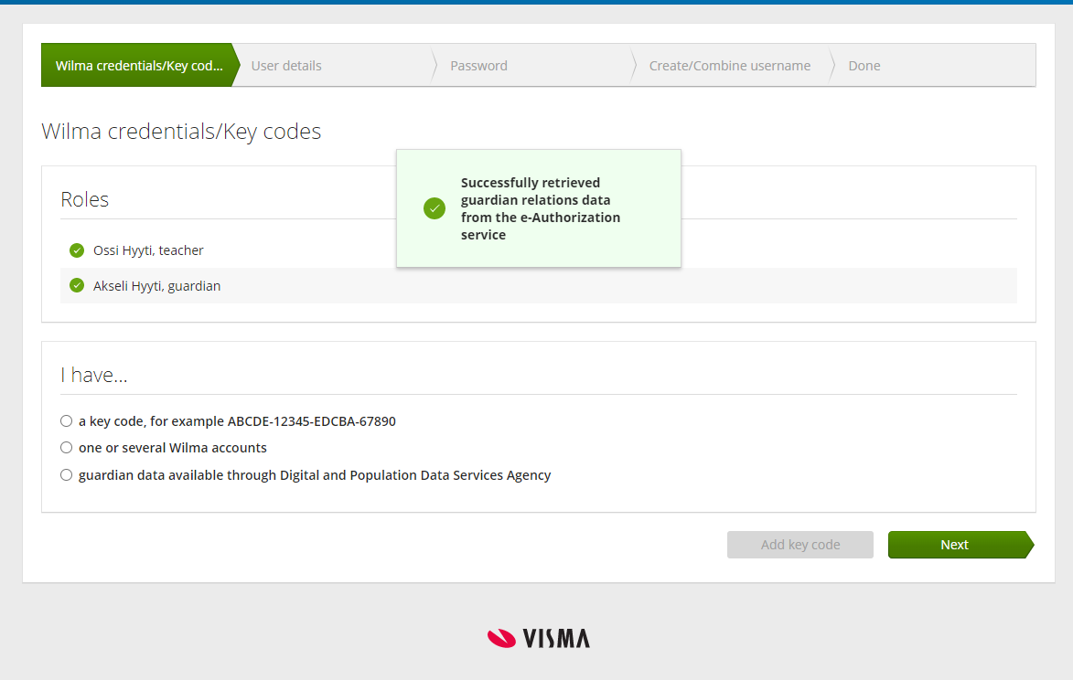
14. Enter your user information and click Next.
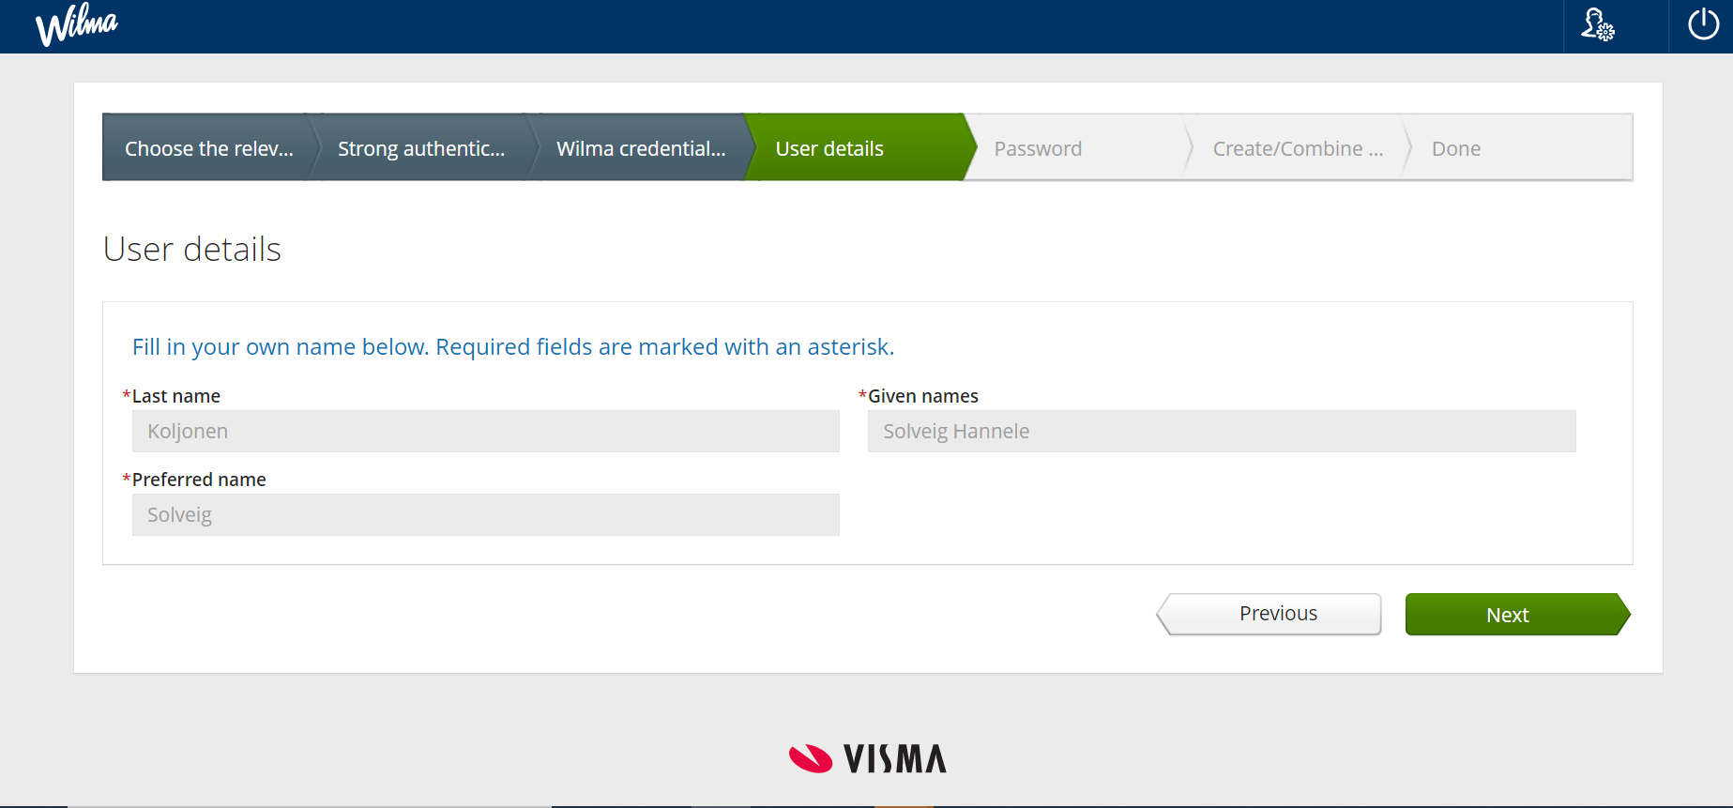

15. Enter a password for your account and click Next.
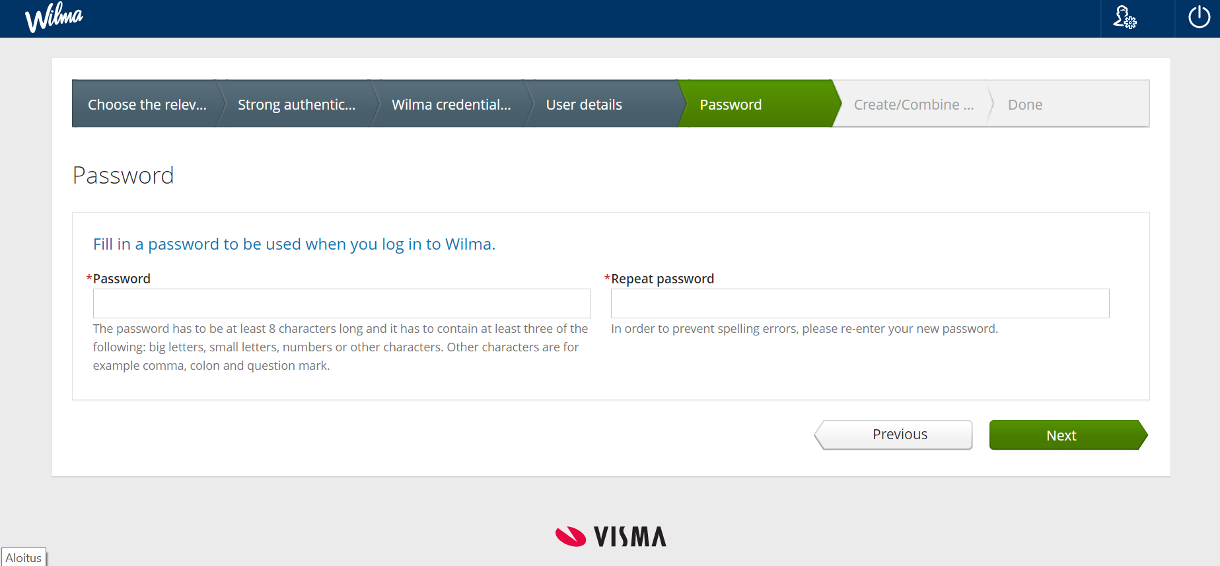
16. Check that the information you have entered is correct. Click Create username. 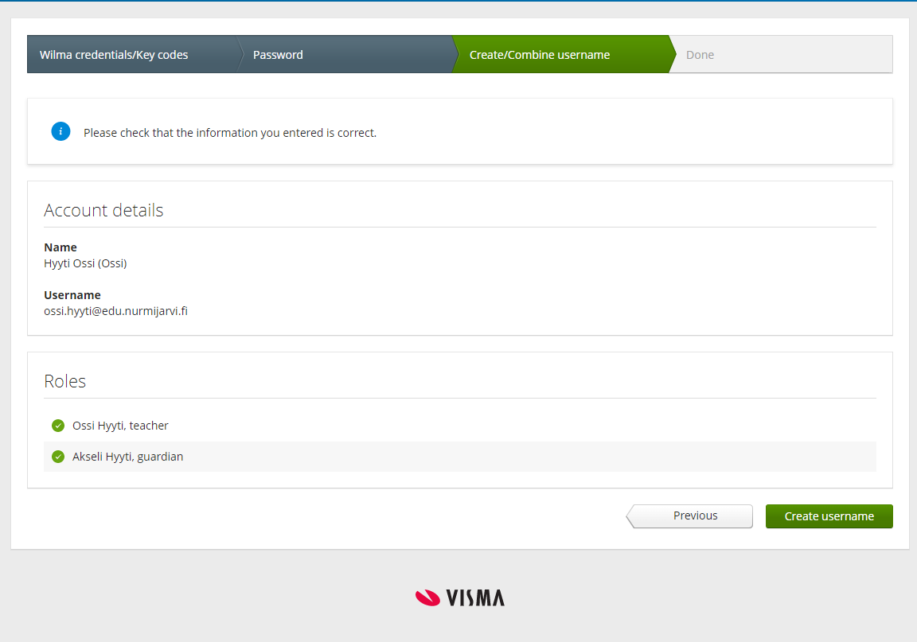
17. You will receive the following notification. You have now created a Wilma account. Return to the homepage or log in with your new account at https://nurmijarvi.inschool.fi.
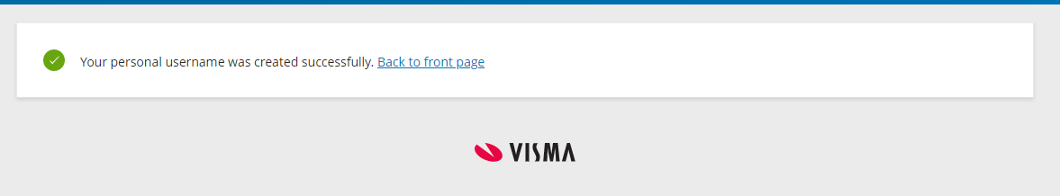

Connecting a child to an existing Wilma account.
Guardians who already have a Wilma account can still connect additional children to their account. You cannot add a child who is in school in another municipality or educational institution.
The following instructions will guide you through connecting a child to your existing account:
1. Log in to your account on Wilma’s browser version at https://nurmijarvi.inschool.fi/ 2. Open the Settings menu (from the blue bar in the top-right of the screen) and click User rights.
3. In the bottom corner of the menu that opens up, click Add role.
4. In the bottom corner, click ‘I have...guardian data available through Digital and Population data services Agency’ and Retrieve person.
5. In the Suomi.fi window that opens, select the child you wish to connect to your account, then confirm and continue.
6. The next screen should display the children already connected to the account (Current roles) and new connections (Nyt lisättävät Roolit). If there are still children you wish to connect to the account, click ‘guardian data available through Digital and Population data services Agency’ again.
7. After you have added all the children you wish to connect to the account, click Next in the bottom corner, then click Connect in the bottom corner of the next screen.
8. Log in to Wilma again and ensure the child or children you added are shown in the system.

